MySQL Assignment 1 – DDL Commands & Constraints
SUBMITTED BY: RESHMA V M
SUBMITTED DATE: 26/10/2026

MySQL is a Relational Database Management System (RDBMS) used to store, organize, and manage data in tables. It uses SQL (Structured Query Language) to create databases and tables and to manage data.

DDL (Data Definition Language) commands
DDL commands are used to define and modify database structures.
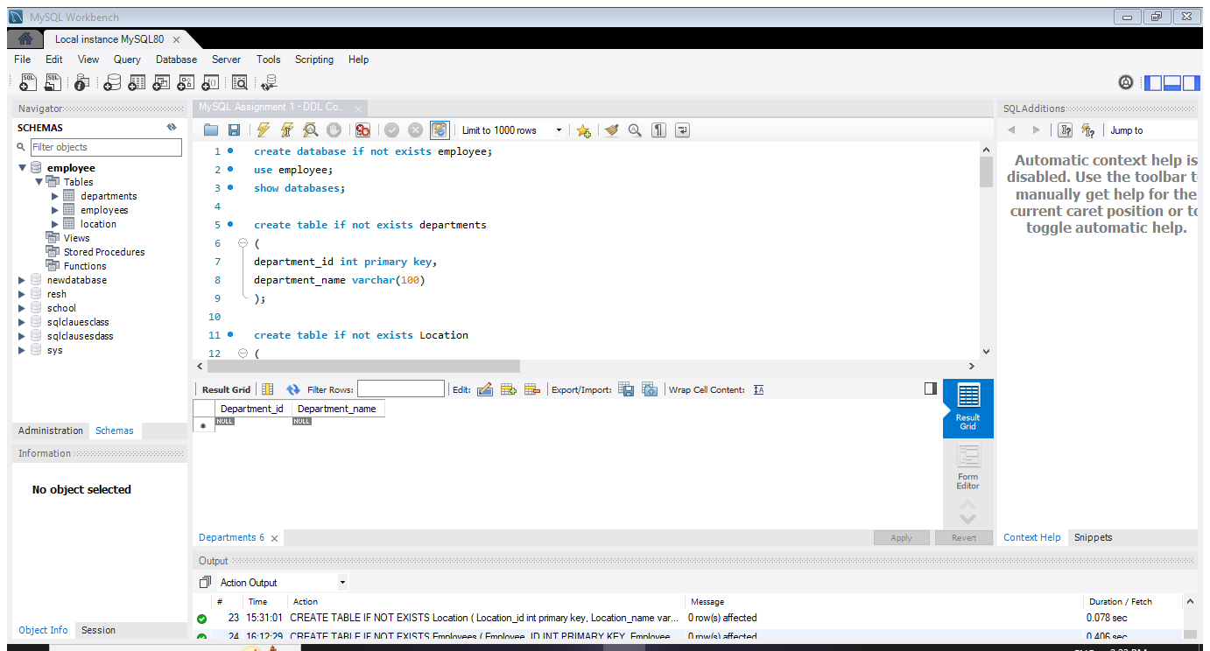
- CREATE: Create the “employee” database and three tables “Departments, Location and Employees”.
Pic: Create employee database

CREATE TABLE command is used to create tables inside a database. Each table stores related information in rows and columns.
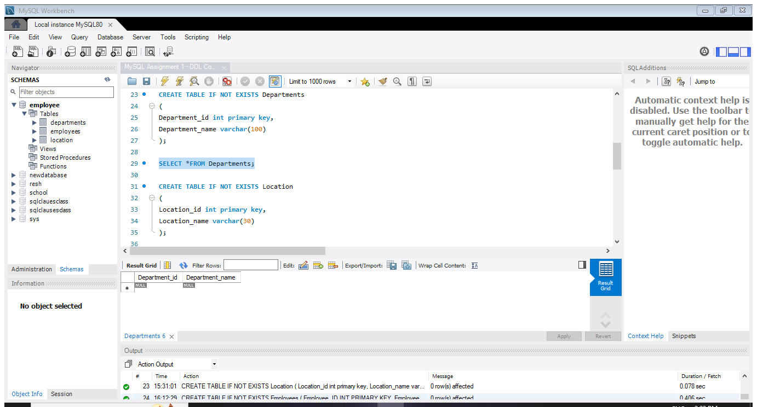
Departments table: Stores department details, such as department ID and department name.
Pic : Department table

Location table: Stores location details, such as location ID and location name.
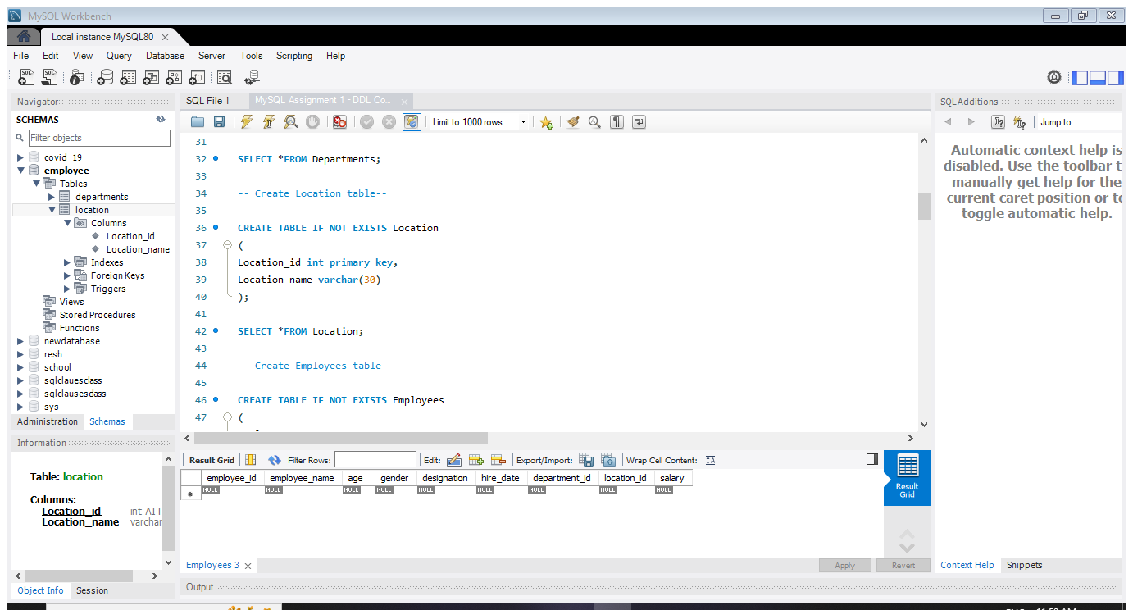
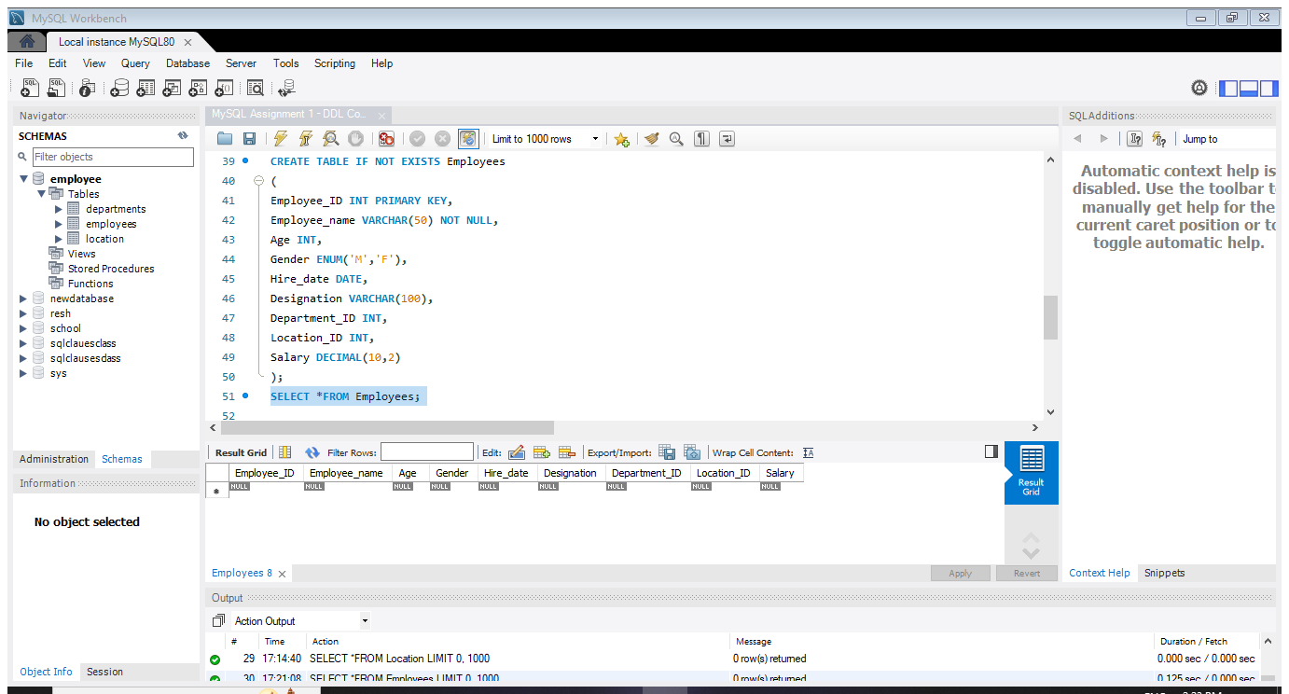
Employees table: Stores employee details, such as employee ID, employee name, age, gender, designation, and hire date.
Pic : Employees table

- Table Alteration (ALTER):
The ALTER TABLE command in MySQL is used to modify the structure of an existing table. It allows us to add new columns, change data types, delete columns, and rename columns.
- Add a new column:
Add a new column named "email" to the Employees table to store employee email addresses.
- Modify the data type:
Modify the data type of the "designation" column in the Employees table to support a wider range of values.
- Rename:
Rename the “hire_date” column to “date_of_joining”.
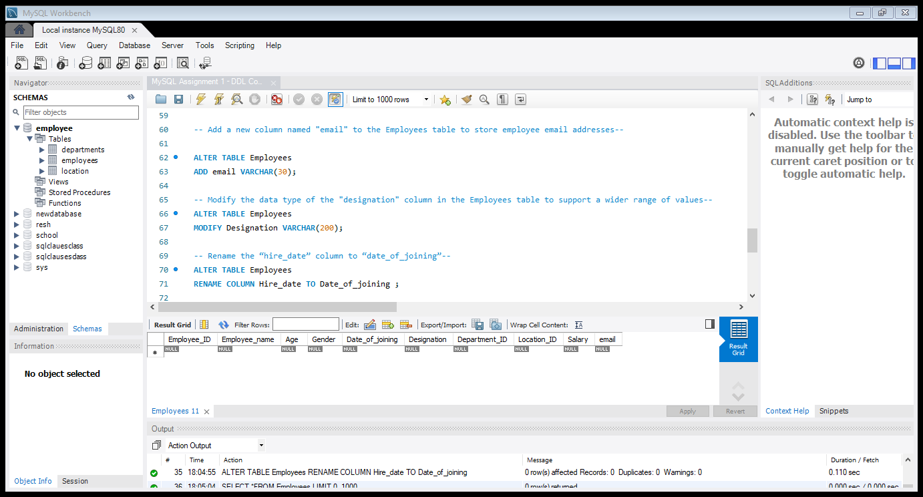
Pic : Alter Employees table

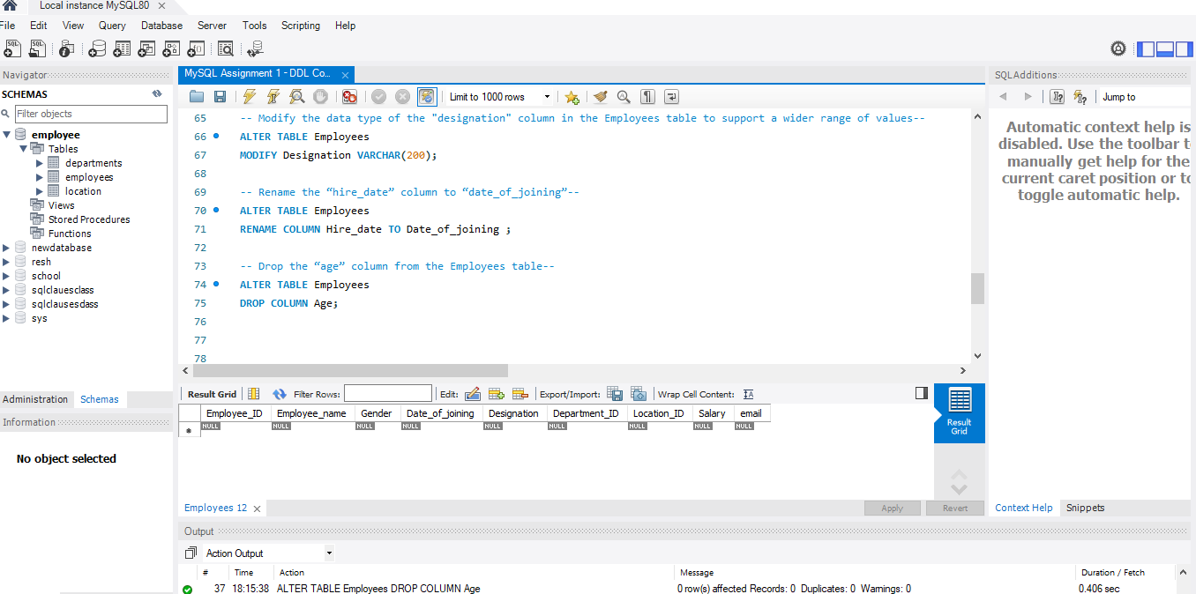
Drop the “age” column from the Employees table.
Pic: Drop column Age

- Table Renaming (RENAME)
- Rename the "Departments" table to "Departments_Info".
- Rename the "Location" table to "Locations"
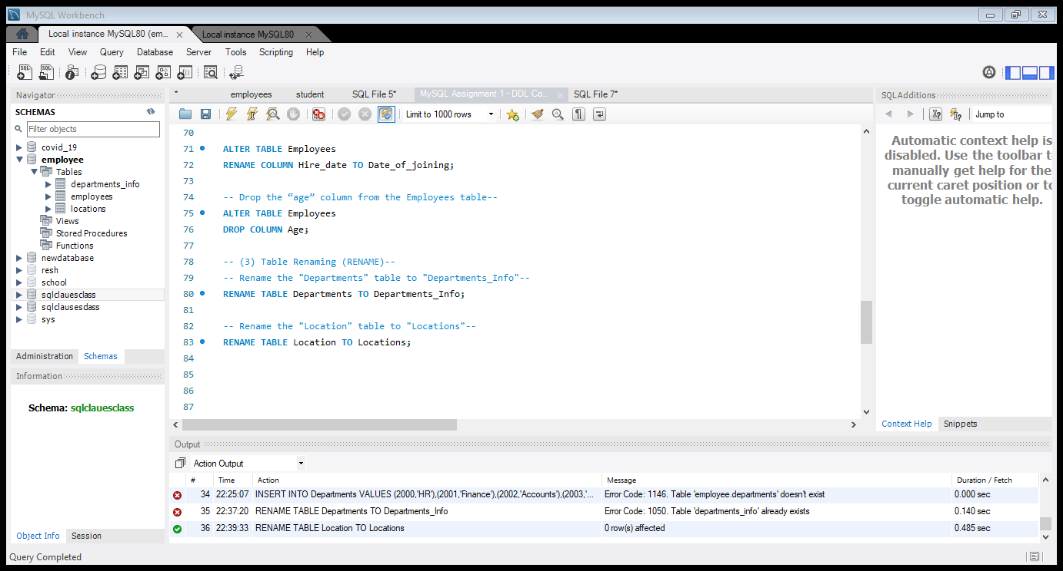

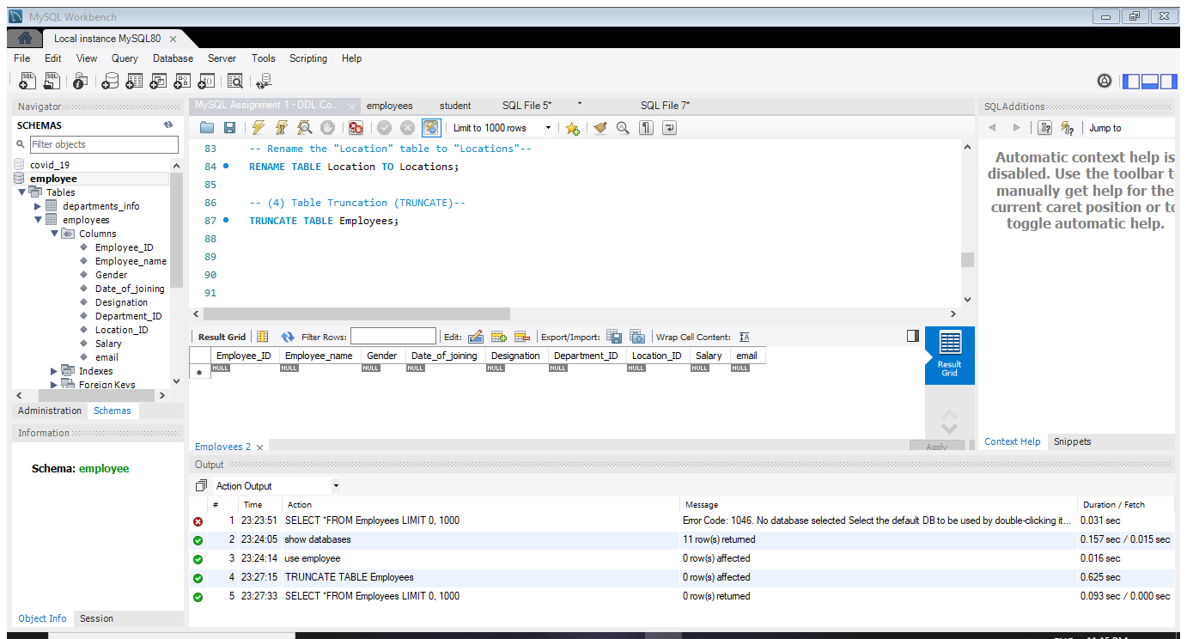
- Table Truncation (TRUNCATE)
- Database & Table Dropping (DROP)
DROP is a DDL (Data Definition Language) command used to permanently delete a database or a table, including its structure and data.
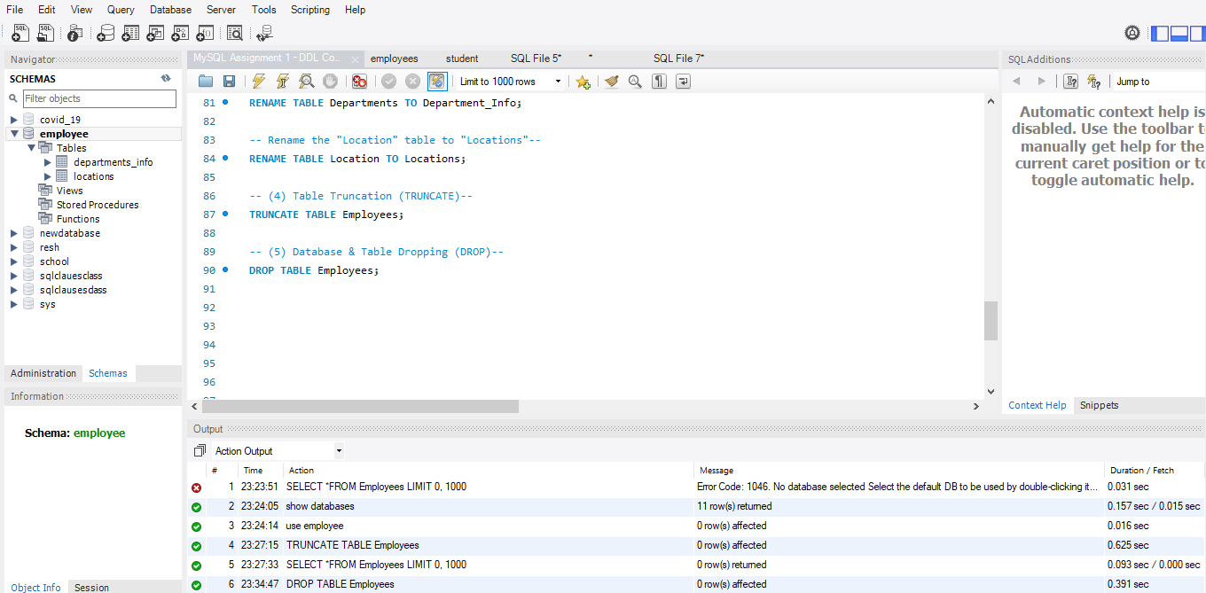
Pic: Drop table Employee

CONSTRAINTS
Constraints are rules applied to table columns to maintain data accuracy and integrity.
- PRIMARY KEY: Uniquely identifies each record.
- NOT NULL: Prevents null values.
- UNIQUE: Prevents duplicate values.
- AUTO_INCREMENT: Automatically generates sequential numbers.
- CHECK: Ensures values satisfy a condition, such as age >= 18.
- DEFAULT: Assigns a default value when none is provided.
- FOREIGN KEY: Establishes a relationship between tables.
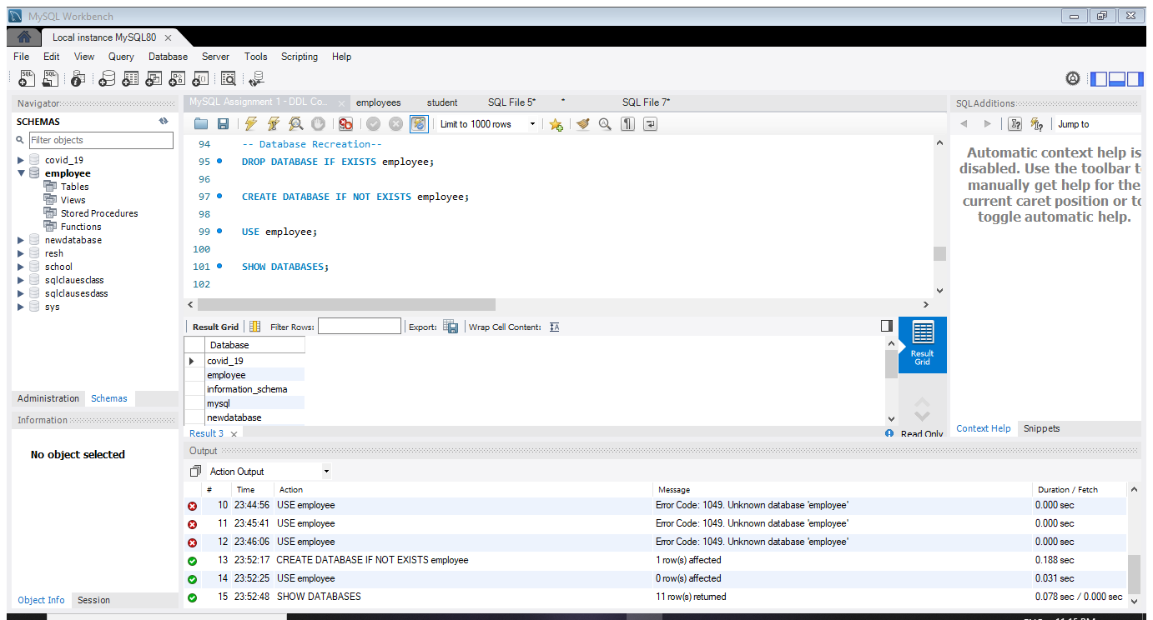
- Database Recreation: Drop the database if it exists, then recreate it.

- Departments Table:
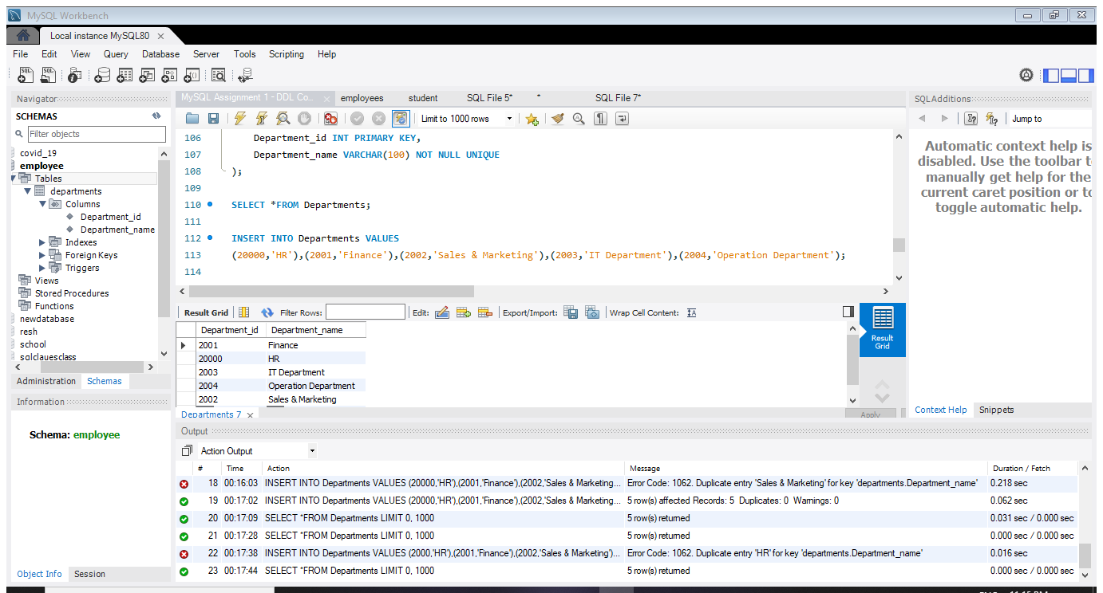
Requirements: Department_id must be unique, and Department_name must not be null or duplicated.
- Location Table:
Requirements: Automatically generate location IDs and prevent null or duplicate location names.
Syntax :
CREATE TABLE Location
(
Location_id INT AUTO_INCREMENT PRIMARY KEY,
Location_name VARCHAR(30) NOT NULL UNIQUE
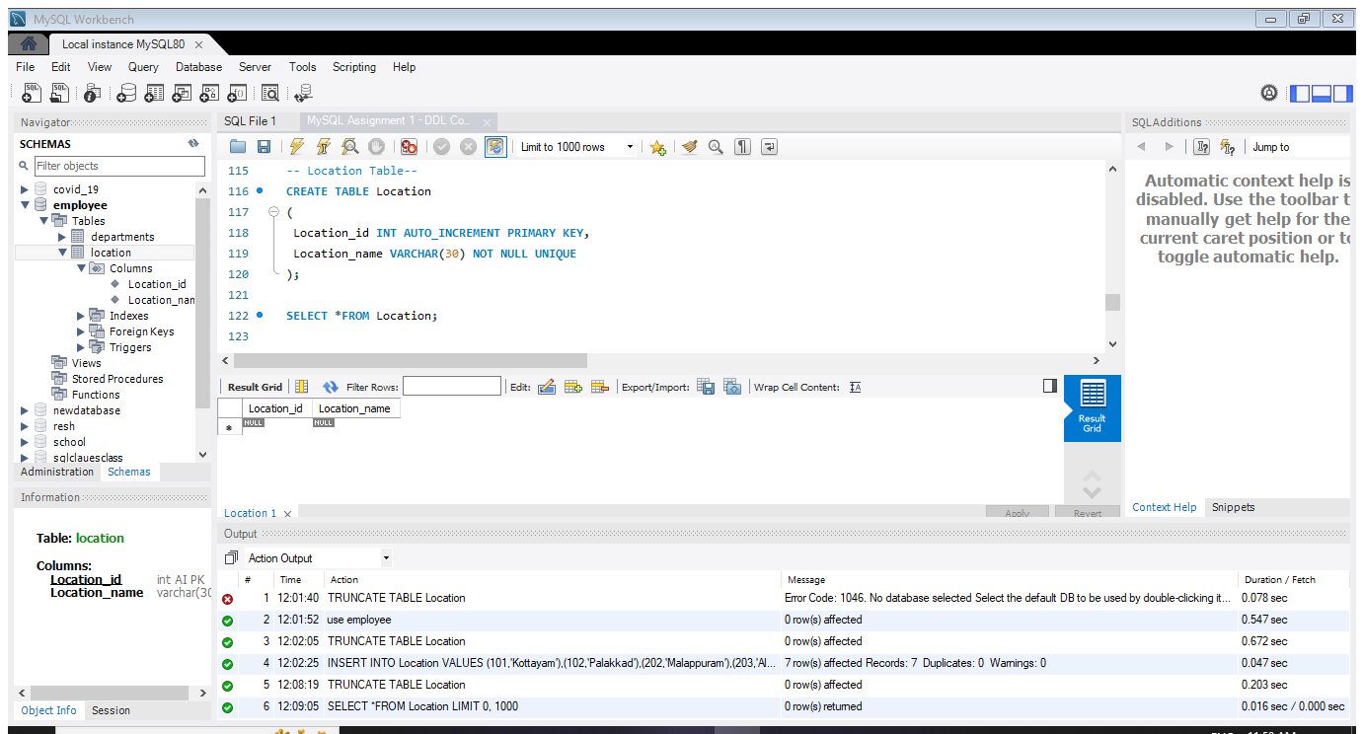
);

Pic : Location table

- Employees Table:
Requirements: Unique employee ID, mandatory employee name, gender restricted to M or F, age at least 18, current date as the default hire date, and foreign keys for department and location.

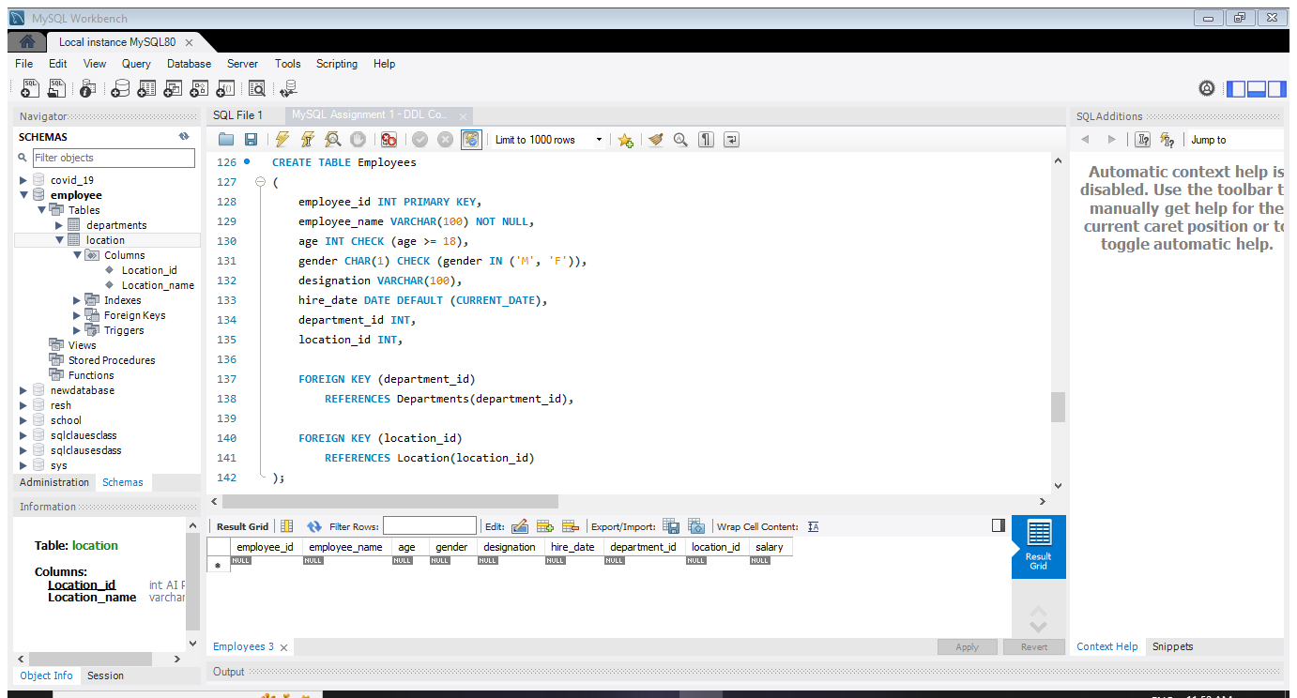

Summary of MySQL DDL Commands and Constraints
MySQL is a Relational Database Management System (RDBMS) used to store and manage data in tables. DDL commands such as CREATE, ALTER, RENAME, TRUNCATE, and DROP are used to create databases and tables, modify table structures, rename tables, remove records, and delete tables or databases. In this assignment, the Departments, Location, and Employees tables are created to organize department, location, and employee details. Constraints such as PRIMARY KEY, NOT NULL, UNIQUE, AUTO_INCREMENT, ENUM, CHECK, DEFAULT, and FOREIGN KEY help maintain data accuracy, prevent invalid entries, and establish relationships between tables. Overall, MySQL commands and constraints help organize data efficiently and maintain database integrity.

******************************************** End *****************************************

